Robot Building

Thomas Schenk

Contents

Introduction 3

Problem 4

Solution 5

Progress 6

Frame Studs 6

Fortifying studs 7

## Introduction

The robot received at the start of this semester was, to say it shortly, in shambles. We received parts only. Some parts already fit, some didn’t.

## Problem

Due to the nature of how we received the project, we have very little knowledge about how the robot must be structured technically. What was/is supposed to be mounted where and why? We are in the dark about the structural planning and assembly of the robot.

## Solution

Document how the robot is build, and if applicable; invent/add new features to the robot to make it more secure, add features etc.

## Progress

To start off, we received a picture from our product owner of how the robot used to look. With this, we could determine how the robot was structured before, and what we might need to change.

Right from the start we could see that this was already very well thought about, though at this moment in time; we also felt like we had a few things to add.

### Frame Studs

Currently there are 6 frame studs installed, though only on the outside. This left the inside still pretty flexy, something we want to remedy. We want to do this by adding 6 more on the inside, this will create a more ridged frame.

A sketch for this looks as follows:  
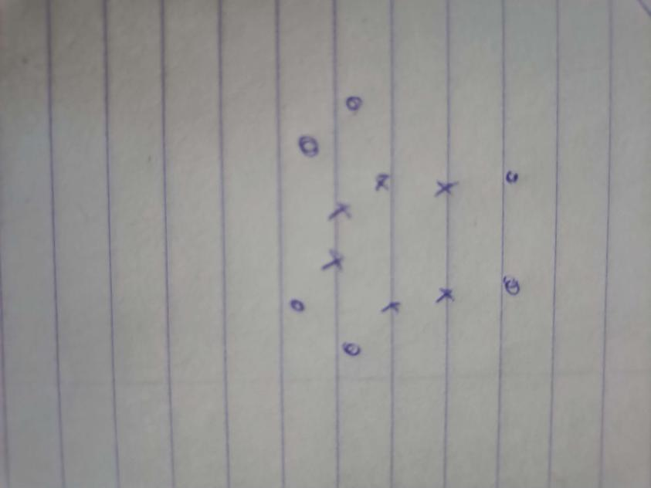

With the circles being pre existing studs, and the crossed being new ones.

In addition to these extra studs, we will also add spacers; since currently the second plank is sitting uneven on the baseplate. This is due to protruding bolts and nuts which are used to secure hardware on this plank.

### Fortifying studs

Aside from adding new studs, we are also increasing the effectiveness of these studs. If we look at the traditional use of studs in other applications, such as engines, we normally see that these studs house another piece of material to which they are torqued down.

In our case, this is not being done! This means that these studs do connect different parts of the robot but are not necessarily making it very ridged.

We can fix this by adding a sleeve over the studs, this way we can put some tension on the sleeve; and therefore the two different parts of the robot. This will result in a stronger bond; with the aim to make the robot a bit more resilient to the contact heavy sport: robot football.

On paper, it looks like this:

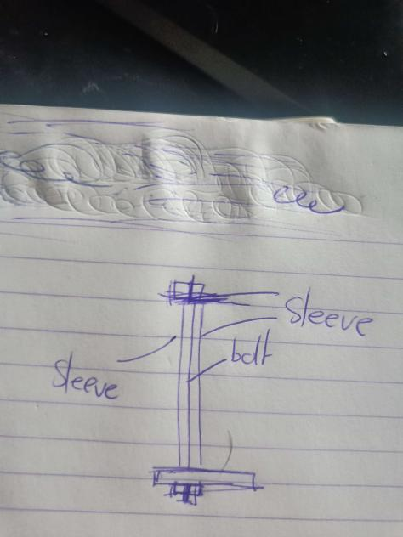

### Assembling the baseplate

With building progressing steadily, we can add the baseplate to the undercarriage of the robot. This baseplate contains all the battery holders, and the motor controllers.

